CryptoGurus

<https://whispering-journey-31015.herokuapp.com/>

Header

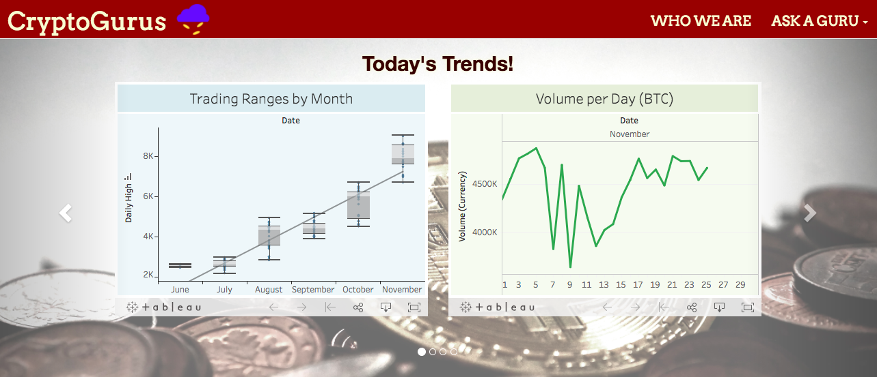

* The Navigation Bar (consistent for all pages)
  + Our emblem in the top left links to the top of our homepage.
  + The “Who We Are” button links to a section further down the page that presents the founders of CryptoGurus and explains our mission.
  + Ask a Guru
    - The first line is an invitation to send an email to the founders. We provide a button that will generate an email when clicked
    - We plan to build in a feature to facilitate chats with those who are interested in trading crypto. We hope to establish a collaborative environment. Here we use an EventBrite link to send a custom calendar invitation to our first chat
* The Carousel
  + On our landing page you are greeted with two Tableau charts which leverage Tableau’s online hosting options. We select the most relevant trends for traders and present them in a visually appealing and interactive manner. We use the crawlers to store necessary date on the server.
  + Scroll right for a link to the investment tool that helps you learn trading techniques that can be applied to cryptocurrencies.
  + Scroll right again for the latest tweet about Bitcoin. If we exceed our pull limit, our backup tweet is an interesting interview that the Winklevoss twins had with Fox. We use the Twitter searcher to pass variables of necessary information regarding the latest Bitcoin tween to run a script in the HTML along with CSS style encoding to present the tween in a familiar way.
  + Scroll right one more time for button that permits users to email us and share their trading story.

Resources

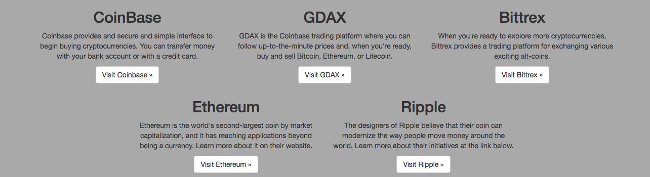

* Trading Sites: We provide links to popular trading sites. We hope that once individuals see how easy applying techniques with which they are familiar to new securities, they put their skills to the test in the marketplace.
  + Coinbase links to a service where individuals can buy and store currency.
  + GDAX links to Coinbase’s active trading platform.
  + Bittrex links to a site that offers a trading platform for a great number of cryptocurrencies.
* Coins of Great Interest: We try to feature popular coins with great management teams who will ideally show individuals that many coins have excellent and visible leadership, just like the leadership of the securities they are used to trading.
  + Ethereum is an open source blockchain technology that is in use beyond just being a currency.
  + Ripple is a coin with a leadership team that has contracted with banks to develop technology that will facilitate international money movement.

**Web Crawlers:**

Execute: ./robots_reader.py

This will display the contents of the robots.txt file. The method is currently set to examine the robots.txt of coinmarketcap.com.

Execute: ./coinmarketcap_crawler.py

The python file contains two classes: Currency and Coin_Market_Cap_Spider which work in conjunction to gather and store value data on cryptocurrencies available on coinmarketcap.com. In the file hierarchy of the present project, a Data directory is created if not already existent and results of the crawl are stored in csv format. A message is printed for each crawl attempt indicating the successful or unsuccessful storage of data, as well as the index of the currency:

[+] 1/50 Crawled: Bitcoin

[-] 2/50 failed to crawl: Ethereum

[+] 3/50 Crawled: Bitcash

...

In the present working directory, a file “log_failures.csv” will report currencies which were not successfully downloaded.

**Analysis code:**

Execute: ./Analyzer.py

Analyzer.py contains classes/methods necessary to parse csv data crawled by the webcrawler and display it meaningfully. When executed alone, the default main method shows a plot of the previous year of available data on the opening price of Bitcoin as a demonstration of output. If imported, specific features, dates, and currencies may be specified:

>>> cca = Crypto_Currency_Analyzer

>>> cca.data_frame(currencies=[“Bitcoin”, “Ethereum”], feature=”CLOSE”])

>>> cca.plot_data_frame(show=True)

When specifying the dataset(s) which will be analyzed, one or more specific parameters may be delineated according to the method definition::

data_frame(self, feature="OPEN", currencies=None, start_date=None, end_date=None)

Available currencies comprise all cryptocurrencies contained in the Data/ directory. Viable features include: OPEN, CLOSE, HIGH, LOW, VOL. Dates must be formatted as “yyyy-mm-dd”.

**Twitter code:**

Execute: ./authorize.py (first time, or if necessary)

Execute: ./Twitter/twitter_searcher.py

The Twitter/ directory contains files and executables necessary for the website’s use of the python-twitter API. authorize.py generates a file ‘credentials.txt’ containing login-authorization info necessary for use of the API. twitter_searcher.py conducts a keyword search of twitter and returns a relevant tweet. If used alone, the main method as a default returns the twitter-id and user-name of a single tweet resulting from a search for the term ‘bitcoin’ in order to demonstrate expected output. Output should be in the form of a tuple:

(942627120961896448, 'johnhallrawks77’)

The twitter-id number may be used to look up the content of the tweet for posting on the landing page of the site.